**Lightwave driven dynamics in topological states**

*Shanghai Institute of Optics and Fine Mechanics, Chinese Academy of Sciences, China*

**Ya Bai**

**Email: pipbear@siom.ac.cn**

New insights into the lightwave driven ultrafast electron dynamics in condensed matter are provided by the high-harmonic generation (HHG) from solids irradiated with an intense laser pulse. The produced HHG behaves nonperturbatively with the increasing of driving pulse intensity and depends sensitively on the symmetry of the solids, thus providing in-depth knowledge of electronic structure, Bloch wavefunction and extreme nonlinear electron dynamics. Using intense laser pulses generated by our home-built long-wavelength infrared laser system, we have been engaged in the study of HHG from novel two-dimensional electron systems, such as topological surface states and monolayer molybdenum disulfide. Here I would like to present our recent progress in the HHG from nontrivial topological states: First, we observe HHG arising from topological surface states in the intrinsic topological insulator BiSbTeSe2. The components of the even-order harmonics with parallel polarization to the driving field arise from the spin polarized current in helical surface states, while the perpendicular components originate from the out-of-plane spin tilt related to the hexagonal wrapping effect. Secondly, we demonstrate the observation of the Berry phase effect in the topological surface states of 3D TIs. This is achieved by measuring the HHG modulation from topological surface states using two-colour field driven high-harmonic interferometry. We find that the interplay of spin-orbital coupling and the lack of inversion symmetry at the TI surface creates a remarkable geometric phase effect and shapes the subcycle electron dynamics. The above findings provide a microscopic perspective to drive the inner degrees of freedom of Bloch electrons by strong light fields.

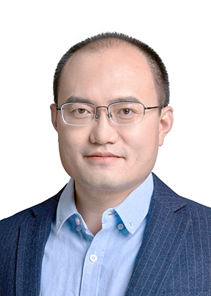**Short Bio:**

**Ya Bai** received his PhD degree in Plasma Physics from the University of Chinese Academy of Sciences, China. He is now a professor at the Shanghai Institute of Optics and Fine Mechanics, Chinese Academy of Sciences, China. His research focuses on strong-field phenomena in new quantum materials, ranging from long-wavelength infrared laser pulse generation to high-harmonic generation.