**Generation of 45-mJ High-Energy Strong-Field THz Radiation from Lithium Niobate Crystals**

*Beihang University, China*

**Xiaojun Wu**

**Email: xiaojunwu@buaa.edu.cn**

Free-space strong-field terahertz (THz) electromagnetic pulses offers unique high-frequency electric field and pulsed magnetic forces and multifaceted spectroscopic capabilities for accelerating particles, driving non-equilibrium quantum states, understanding the mesoscale low-energy vibrations of macromolecules in (bio)materials. However, the key obstacle to these applications lies in the lack of high efficiency, high beam quality, and high stability radiation sources. Lithium niobate materials have the advantages of high nonlinear coefficient, large crystal size, high damage threshold, and are one of the best candidates for generating strong-field THz radiation. However, using the existing ultra-strong ultra-short Ti:sapphire femtosecond laser pulses to pump lithium niobate crystals and efficiently generate strong-field THz radiation, there are at least three major problems and challenges need to be overcome: phase mismatch caused by refractive index difference, low efficiency caused by intrinsic short pulses, and nonlinear effects caused by high pump intensity. In this talk I will present our recent efforts on how to solve these difficulties and consequently obtain 45-mJ single-pulse energy of THz radiation from cryogenically cooled stacked six large-size lithium niobate crystals driven by petawatt SULF-laser facility.

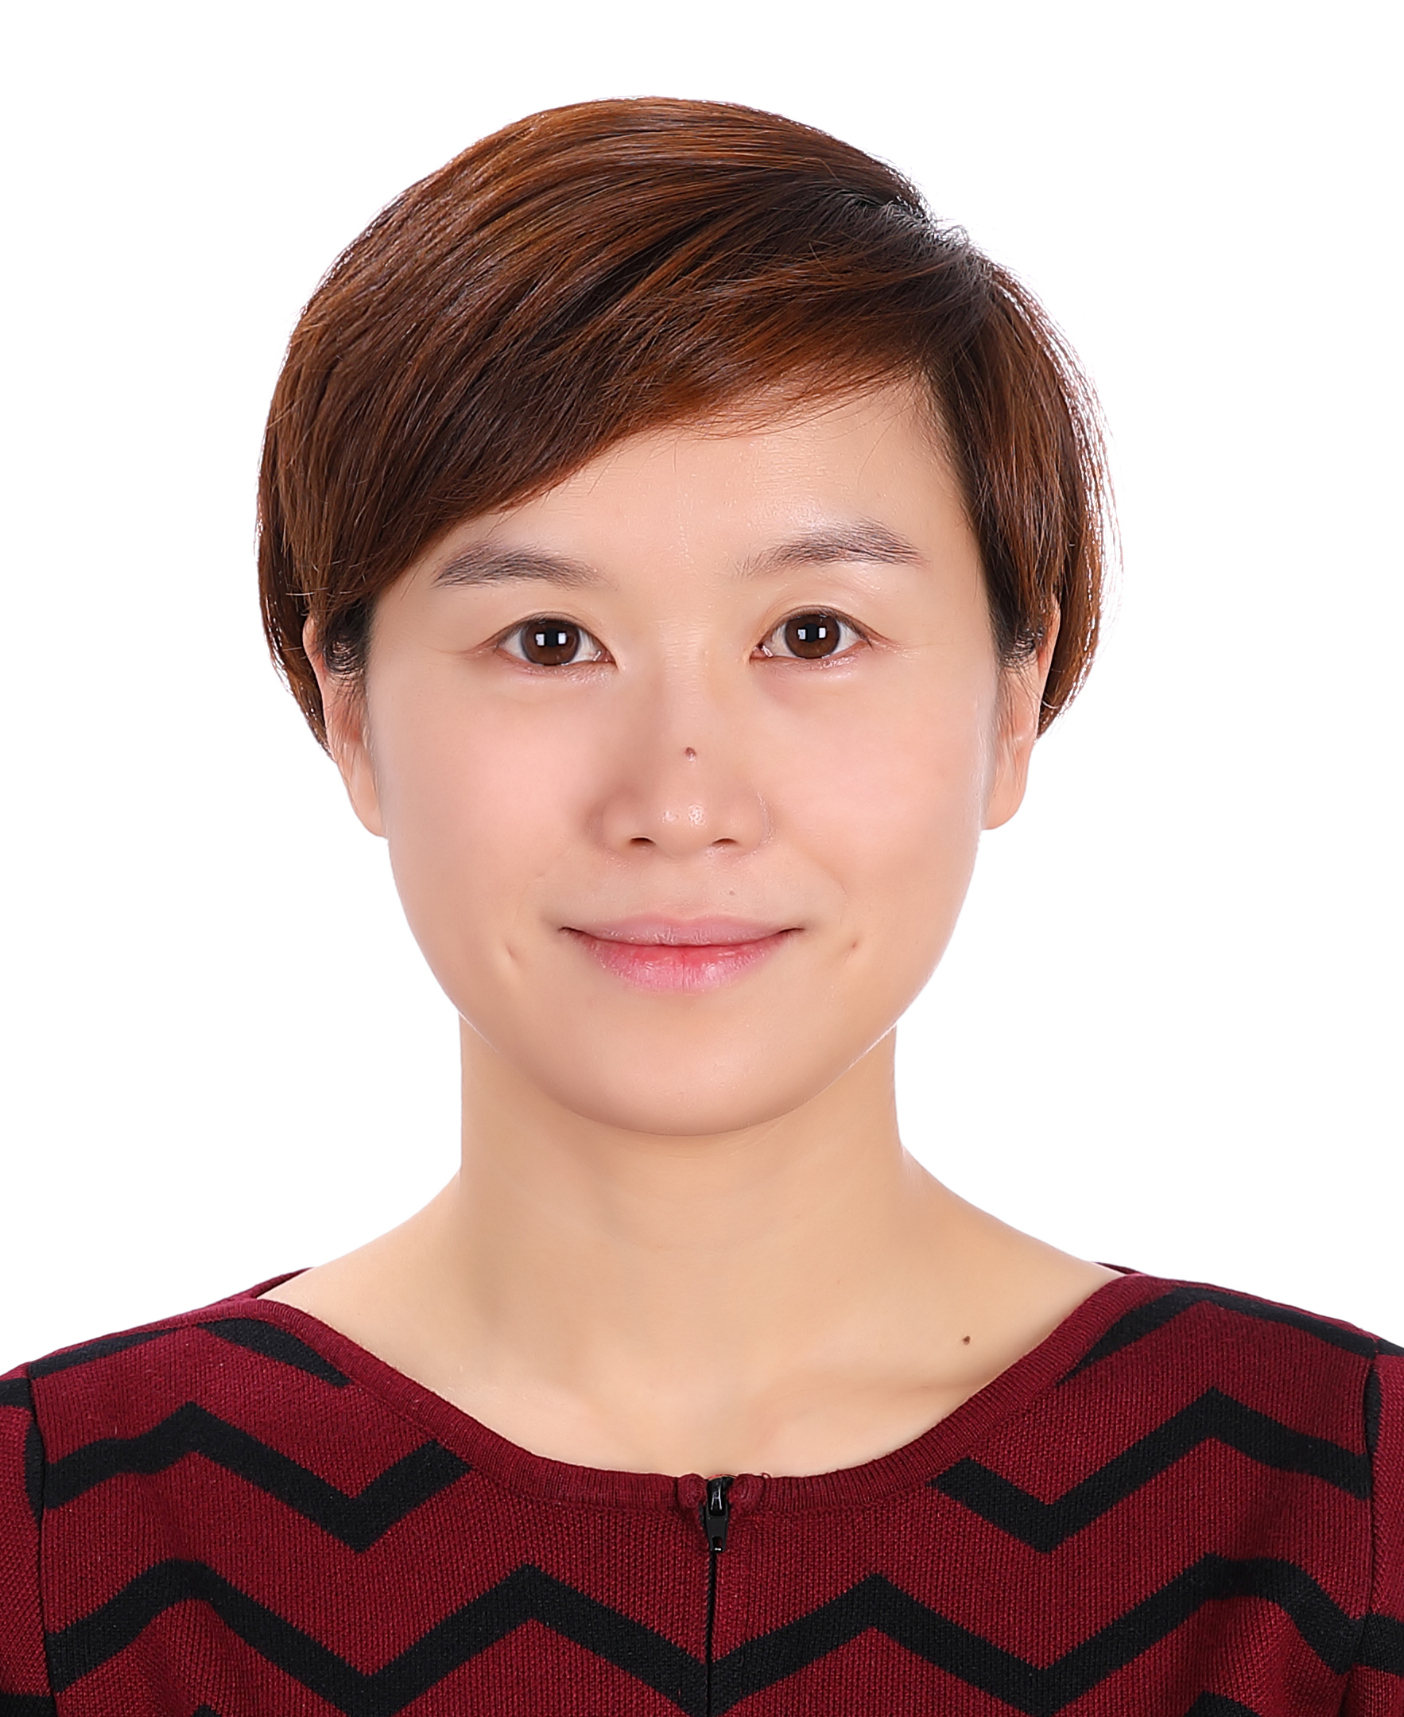**Short Bio:**

**Xiaojun Wu** received his PhD degree in the Institute of Physics, CAS. She joined in Beihang University in the May of 2017 after she completed his Humboldt Fellowship at DESY in Germany. Her research interests are generating high-energy strong-field THz radiation and its applications. She was awarded the first Zhenyi Wang Award by International Society of Infrared, Millimeter, and THz Waves, the first Women in Ultrafast Science Global Award, the first prize of the first China Science and Technology Youth Forum and Optica Fellow.