**High-efficiency broadband achromatic metalens for terahertz regime**

*Beijing Institute of Technology, China*

**Cheng Chi**

**Email: cheng.chi@bit.edu.cn**

Terahertz electromagnetic waves have been widely used in non-destructive testing, environmental monitoring, safety inspection, etc. However, the lack of integrated functional devices limits development and applications in terahertz imaging technology. Metasurfaces effectively manipulate electromagnetic waves at nanoscale, providing an efficient solution to design integrated terahertz functional devices. Terahertz metalens as a core element in imaging devices, faces chromatic aberration issues that significantly affect imaging results with broadband terahertz wave incidents. The approach to designing wide-band, achromatic, high-efficiency metalenses is a hot spot in applied terahertz devices.

Here, we designed an achromatic metalens with polarization-insensitive silicon structural elements working from 1.2 to 1.8 THz. The designed metalens possesses a high working efficiency at the peak value of more than 50% and a numerical aperture of 0.3. The maximum deviation of focal length and average focusing efficiency of the proposed achromatic metalens at the whole working frequency range is 6.7% and 41.3%, respectively. Our work lays the foundation for the miniaturization and practical applications of terahertz imaging technology, and paves the way for broadband achromatic metalens applications in medical diagnosis and industrial flaw detection.

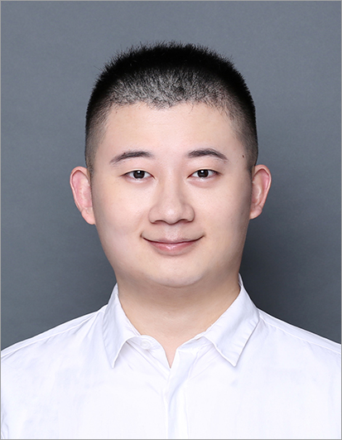**Short Bio:**

**Cheng Chi** received his PhD degree in School of Physics from Peking University, China. He is an assistant professor of Beijing Institute of Technology, with National Program for Support of Young Elite Scientist Award of China in 2022. Prof. Chi focuses on the new type of nanophotonic device principle, materials and applications, experimentally and theoretically analyzed the metamaterials, near field optics, applications in AR/VR display and sensing. Prof. Chi published more than 20 SCI peer reviewed papers, including 10 papers that published in Sci. Adv., Adv. Sci., Phys. Rev. Lett., Small, and other journals with SCI impact factor IF>10. All of the publications were cited more than 1000 times. Related works were highlighted by Nature Reviews Materials, Chemical Reviews and other top profile journals. Prof. Chi was invited to attend international conference to deliver the invited talk including Photonics Asia, the 69th Lindau Nobel Laureate Meeting, *etc,* and serves as a member of Lindau Alumni.