**Lanthanide Transducers for Advanced Imaging and Assistive Technology**

*National University of Singapore, Singapore*

**Xiaogang Liu**

**Email: chmlx@nus.edu.sg**

Imaging technology has revolutionized our understanding of the world, from medical diagnosis to astronomical exploration. Advancements in imaging tools have led to significant breakthroughs across various sectors. The field continually evolves, with technologies like lanthanide doping in optical nanomaterials emerging as a promising research area. This technique aims to improve image resolution and open up new application possibilities. Lanthanides are notable for their specific light absorption and emission capabilities, useful in frequency conversion to change light into new wavelengths. Photon upconversion, a notable research area, converts low-energy photons to higher-energy ones, enhancing imaging, bio-detection, therapy, and X-ray scintillation. I will also discuss recent advancements in electronic assistive technologies for individuals with disabilities, highlighting the transformative potential of these innovations.

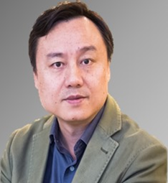**Short Bio:**

**Xiaogang Liu** received his Ph.D. from Northwestern University, USA (2004). After spending two years as a postdoctoral researcher in the Department of Materials Science and Engineering at MIT, he joined NUS in 2006 and was promoted to Full Professor in 2017. Among his research interests are the study of energy transfer in lanthanide-doped nanomaterials, the application of optical nanomaterials for neuromodulation and light-field imaging, the development of advanced X-ray imaging scintillators, and the prototyping of electronic tools for assistive technologies.