**Topological Quantum Photonics**

*Peking University, China*

**Jianwei Wang**

**Email: jww@pku.edu.cn**

We will discuss our recent progress in the field of topological quantum photonics in this talk. Our talk will cover various aspects, including the generation of topologically-protected entangled photons, observations of fast nonlinear-driven topological non-Hermitian phase transitions that occur in the picosecond timescale. These phenomena have been implemented in photonic Floquet insulators that rely on a two-dimensional lattice of couple-mirroring resonators. Furthermore, we will discuss a type of fully programmable topological insulator.

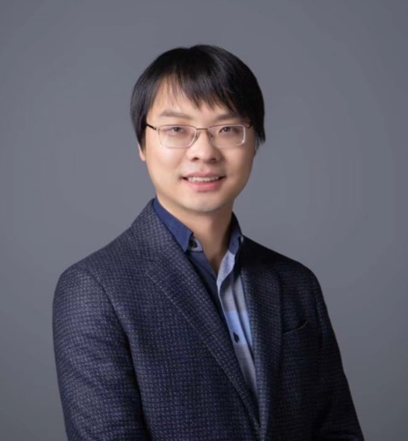**Short Bio:**

**Jianwei Wang** is an Assistant Processor in the Physics of Peking University. He obtained his PHD in the University of Bristol in 2016. His group focuses on quantum information science and technologies with integrated optics. The group is developing large-scale integrated quantum photonic devices for applications in the fields of quantum computations, quantum simulations and quantum communications, as well as for the understanding of fundamental respects of quantum physics. He has published more than 40 peer-reviewed papers in Science, Nature Physics, Nature Photonics, Nature Review Physics, Nature Computational Science, Nature Communications, Science Advances, PRL and Optica.