**Highly-efficient realization of room-temperature strong coupling quantum states**

*Sun Yat-Sen University, China*

**Xue-Hua Wang**

**Email: wangxueh@mail.sysu.edu.cn**

Room-temperature quantum state is the key foundation for the development of high-performance micro-nano quantum optoelectronic devices, quantum computation and solid-state quantum chips. However, due to the huge dissipation, the quantum states and their devices are extremely difficult to work at room temperature. The room-temperature strong coupling between excitons and photons provides an effective solution to realize artificial room-temperature quantum states. Over the past more than two decades, the only method of achieving the room-temperature strong coupling is to greatly improve the exciton-photon coupling strength for overcoming the huge dissipation. The plasmonic microcavities has been applied for this purpose, which is difficult for scalability and miniaturization. Here, we demonstrate that the room-temperature strong coupling of a single exciton and single nanoparticle can be realized by the non-cavity plasmonic modes highly localized in cuboid nanorods, which opens a pathway to the massive construction of room-temperature solid qubits. However, the room-temperature strong coupling achieved by improving the coupling strength is accidental events with very low probability of less than 1% due to harsh critical conditions. To overcome this challenge, we present a highly-efficient approach for achieving the room-temperature strong coupling by reducing the critical interaction strength at the exceptional point based upon the damping inhibition and matching of the coupled systems, which dramatically relaxes the harsh critical conditions and significantly improves the success rate from about 1% to 80%. Our work will advance in room-temperature quantum devices based on strong coupling single-qubit.

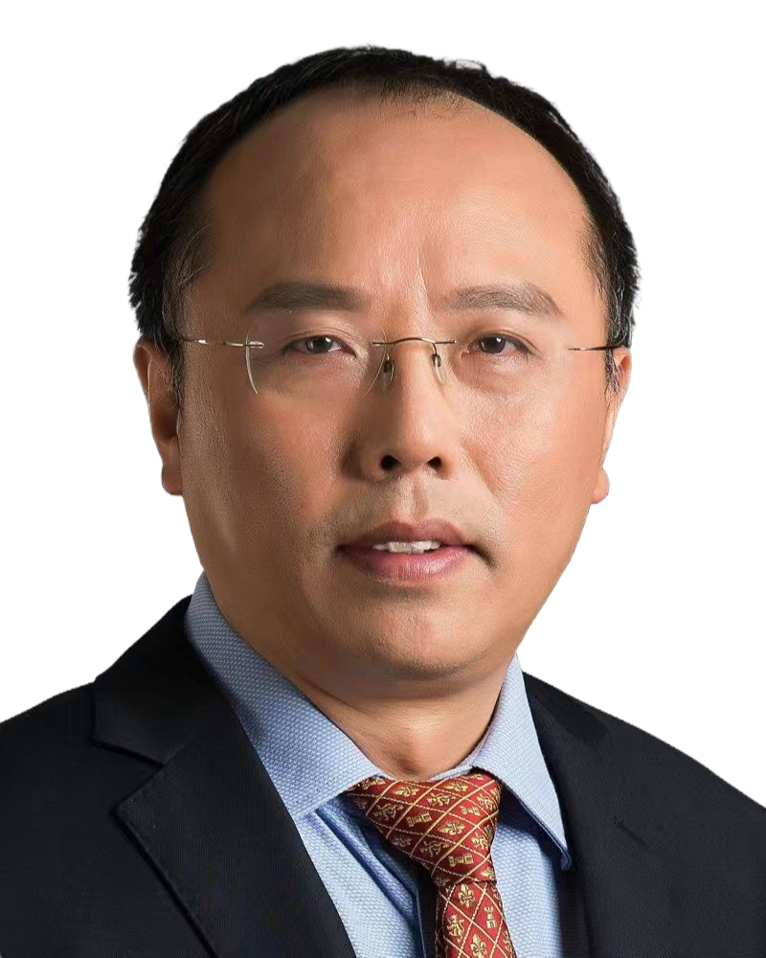**Short Bio:**

**Xue-Hua Wang** received his PhD degree in Condensed Matter Physics from Shanghai Jiao Tong University, China. He is a professor of Sun Yat-Sen University, China.