Quantum light sources on silicon nitride PICs: bulk nonlinearity, heterogeneously-integrated quantum dots, and vapor-phase atoms

National Institute of Standards and Technology, Gaithersburg, MD USA
Joint Quantum Institute, NIST/University of Maryland, College Park, MD USA

Kartik Srinivasan
Email: kartik.srinivasan@nist.gov

Silicon nitride, with its wide optical transparency window, relatively high refractive index, low optical loss, and silicon photonics compatibility, is one of the most heavily investigated photonic integrated circuit (PIC) platforms. In this talk, I will describe three approaches for quantum light generation in this platform and will contrast their relative merits and challenges. The first approach utilizes the bulk third-order nonlinearity of the material, which we harness within dispersion-engineered microresonators to realize entangled photon-pair sources whose output colors are highly non-degenerate and can be widely controlled, but are fundamentally probabilistic in nature. The second approach uses heterogeneously-integrated III-V epitaxial quantum dots, whose short radiative lifetime and on-demand nature are advantageous, but whose decoherence mechanisms and inhomogeneous broadening necessitate special consideration. The final approach integrates alkali atomic vapors with silicon nitride photonics and provides a path towards streams of controllable and indistinguishable photons, though important challenges associated with the atoms’ limited transit time must be overcome.
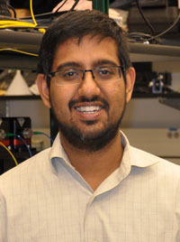
Short Bio:
Kartik Srinivasan received his PhD degree in Applied Physics from the California Institute of Technology (Caltech). He is a Fellow of the National Institute of Standards and Technology in the USA and an Adjunct Professor of Physics and Fellow of the Joint Quantum Institute at the University of Maryland, USA.

