**Nonlinear metaphotonics empowered by resonances**

Yuri Kivshar1

1 Nonlinear Physics Center, Australian National University, Canberra ACT 2601, Australia

* Correspondence to: yuri.kivshar@anu.edu.au

Abstract: Recent progress is subwavelength optics is driven by the physics of optical resonances. This provides a novel platform for localization of light in subwavelength photonic structures and opens new horizons for metamaterial-enabled photonics, or metaphotonics. Recently emerged field of Mie-resonant metaphotonics (also called "Mie-tronics") employs resonances in high-index dielectric nanoparticles and dielectric metasurfaces and aiming for novel applications of the subwavelength optics and photonics. High-index subwavelength resonant dielectric structures emerged recently as a new platform for nanophotonics. They benefit from low material losses and provide a simple way to realize magnetic response which enables efficient flat-optics devices reaching and even outperforming the capabilities of bulk component. In this talk, I will summarize the recent advances in the field of nonlinear metaphotonic with applications to extreme nonlinear effects and nonlinear metasurfaces, including enhancement of light-matter interaction for nonlinear chiral metadevices and metasurfaces.

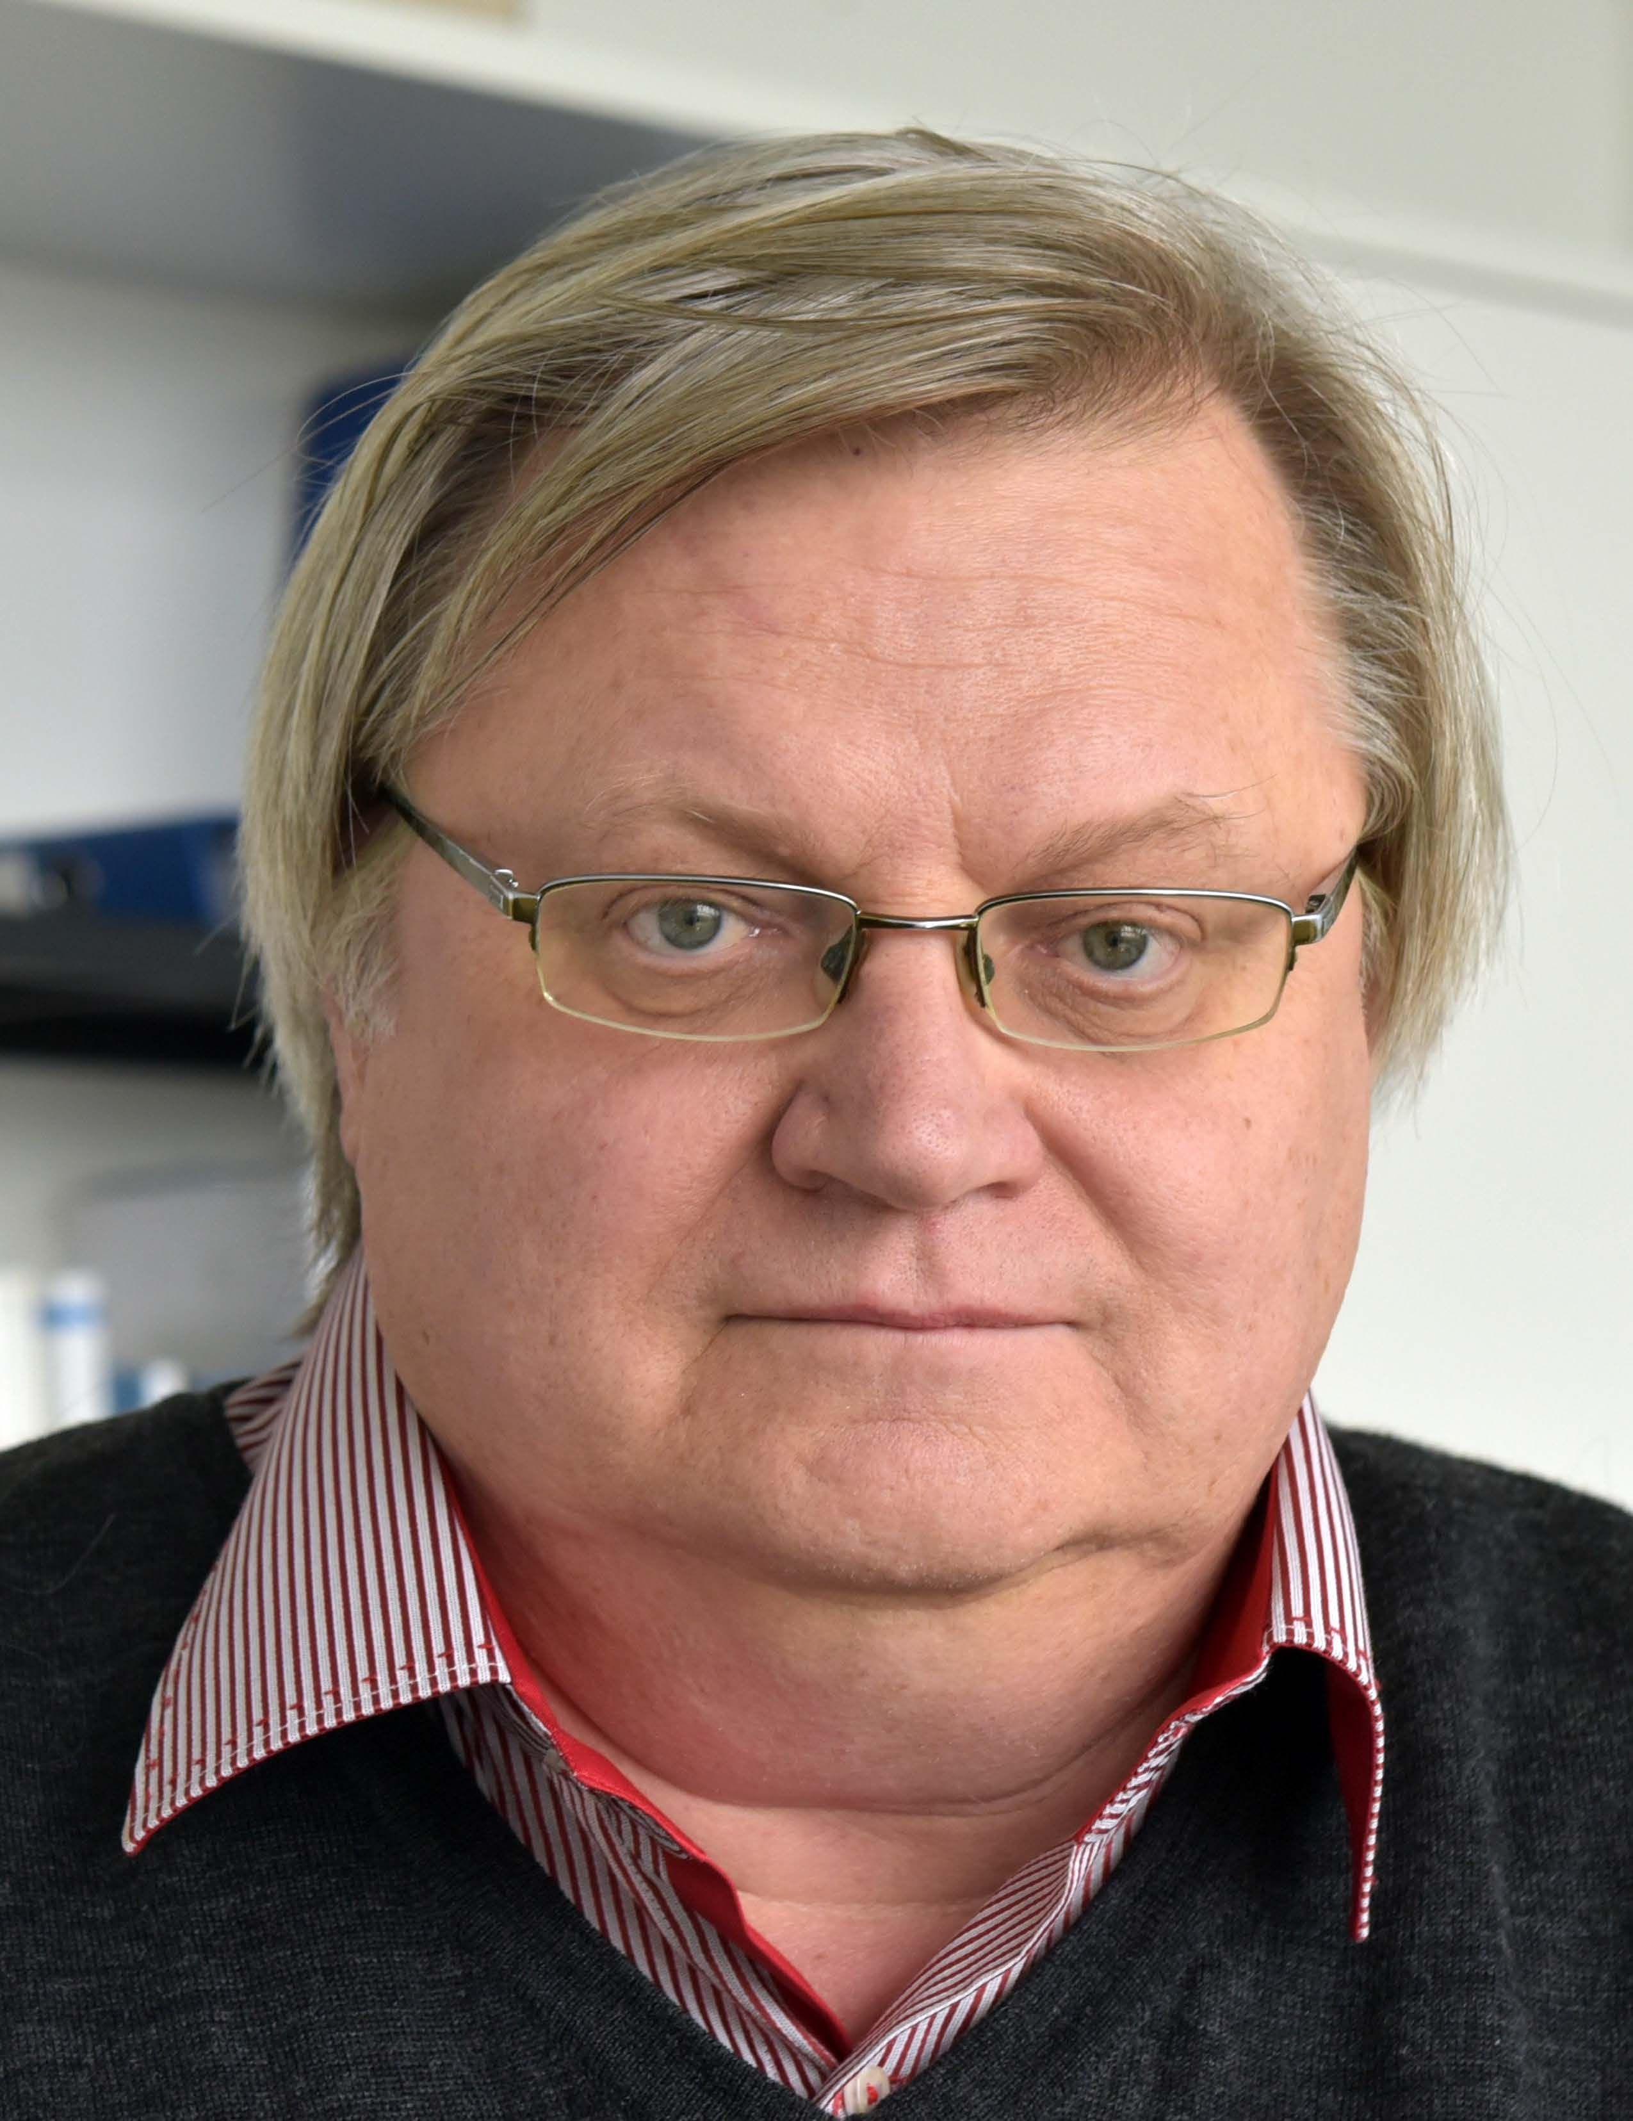**Short Bio:**

Yuri Kivshar received PhD degree in 1984 in Kharkov (Ukraine). In 1993 he moved to Australia where he established Nonlinear Physics Center at the Australian National University. His research interests include nonlinear physics, metamaterials, and nanophotonics. He is Fellow of the Australian Academy  of Science since 2002. He received many awards for his research, more recently 2022 Max Born Award from Optica (formerly Optical Society of America).