**Computational augmentation of optical coherence microscopy**

*University of Tsukuba, Japan*

**Yoshiaki Yasuno**

**Email: yoshiaki.yasuno@cog-labs.org**

The recent development of drug development and basic clinical science heavily rely on in vitro, ex vivo and small animal imaging. For these imaging, a modality with a high imaging depth, high resolutions and a label-free tissue activity visualization capability is required. Although optical coherence microscope (OCM) can be potentially used for such imaging, OCM has a trade-off between the imaging depth and the lateral resolution. In addition, it can visualize only the tissue morphology, i.e., it has no sensitivity to tissue activity.

In order to solve these problems, we introduce computational augmentation techniques to OCM. The computationally-augmented OCM (CA-OCM) is equipped with following functions. (1) It gives high resolution through a millimeter imaging depth by exploiting holographic signal processing. (2) It gives phase contrast images in back-scattering mode. It enables the assessment of structures smaller than the OCM resolution. (3) CA-OCM volumetrically visualizes the tissue activity, such as metabolism and apoptosis. It is enabled by time analysis of sequentially acquired OCM signals, and is recently referred to as dynamic OCT. (4) It gives fully three-dimensional polarization imaging, so it is a volumetric polarization microscopy.

This talk mainly features the third function, the tissue activity imaging. The principle, theoretical details, numerical analysis of the imaging property, and *in vitro* and *ex vivo* applications are discussed.

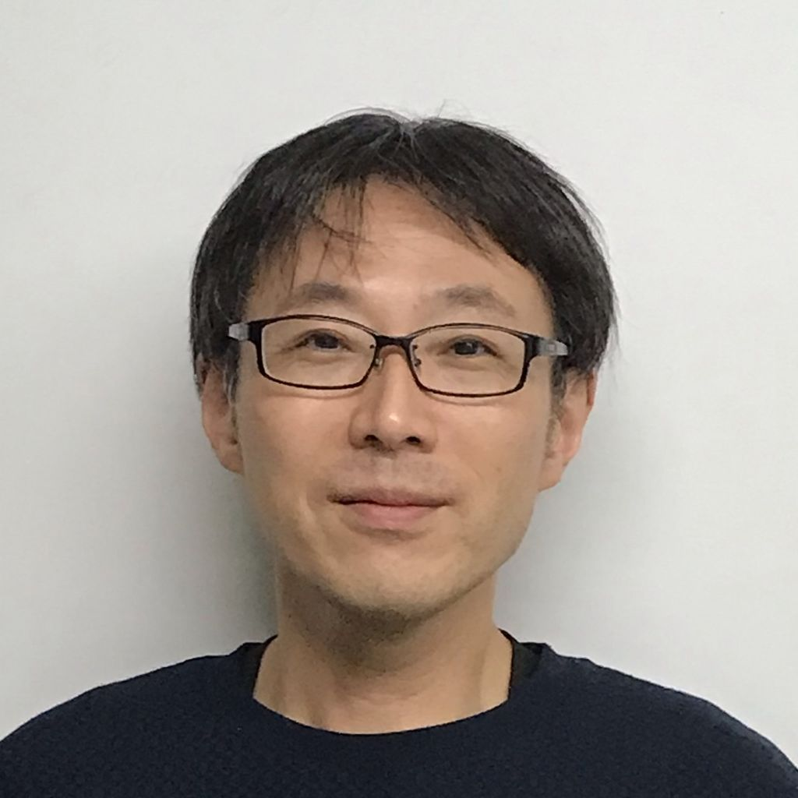**Short Bio:**

**Yoshiaki Yasuno** leads Computational Optics Group at the University of Tsukuba. He obtained his PhD for spatio-temporal optical computing in 2000 and extend this conception to optical measurement including Fourier-domain optical coherence tomography (OCT). His current research interests cover multi-functional optical coherence microscopy, its augmentation by using computational technologies, and theoretical modeling of modern metrology.