**Publishing your papers in Nature journals**

*Nature Photonics, United Kingdom*

**Rachel** **Won**

**Email:** [**r.won@nature.com**](mailto:r.won@nature.com)

In this talk, Rachel will tell you all you need to know about publishing your work in Nature journals, right from preparing your manuscript and options you have during your submission, through to the editorial and review processes.

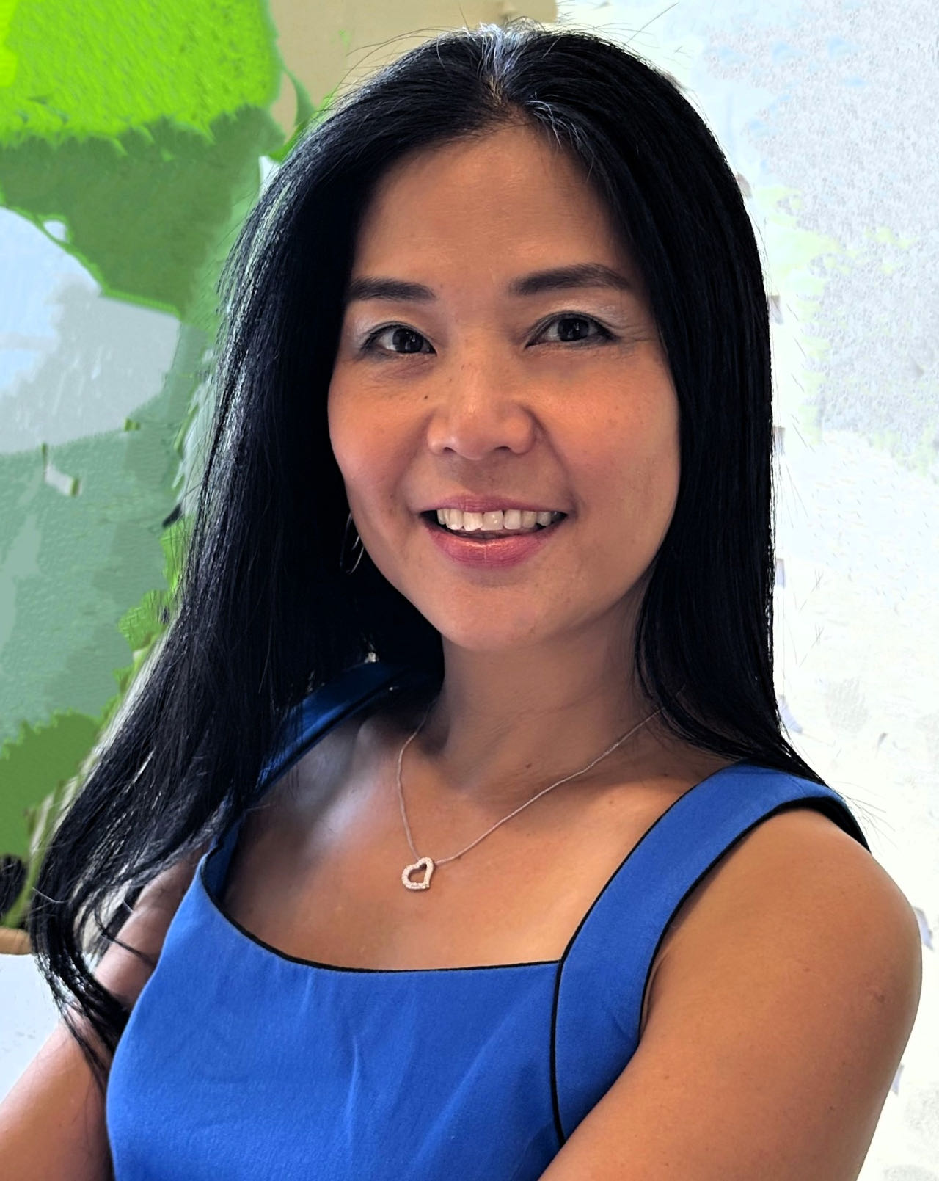**Short Bio:**

**Rachel Won** is an International Editor of *Nature Photonics*. She joined the journal in June 2006 as one of four Founding Editors. Before that, Rachel worked for Aston University's Business Partnership Unit in Birmingham, UK, as a Medici Fellow commercializing research output of the university, particularly that of photonics research. She obtained her PhD in microwave photonics and nonlinear optics as a member of Aston's Photonics Research Group. She worked for Philips Optical Storage in Singapore as an Optics Engineer after completing her Master's degree study in Nanyang Technological University of Singapore doing research in optical fibre sensing. She holds a Bachelor's degree from the National University of Malaysia. She is a Fellow of the OPTICA and the International Society of Optics and Photonics (SPIE).