Active metasurfaces
Uriel Levy¹
¹ Institute of Applied Physics and the center for nanoscience and nanotechnology, The Hebrew University of Jerusalem, Israel
* Correspondence to: ulevy@mail.huji.ac.il

Abstract: We present our recent results related to active metasurfaces. Several mechanisms for implementing active devices will be discussed. We will describe the demonstration of tunability in dielectric and metallic metasurfaces for diverse applications using tunability mechanism such as MEMS technology integrated with metasurfaces and the electro optic effect in lithium niobate integrated with metasurfaces, as well as the tunability of a metasurface by controlling an external medium. We also discuss the role of nanoscale structures in enhancing functionalities such as light emission and light detection.

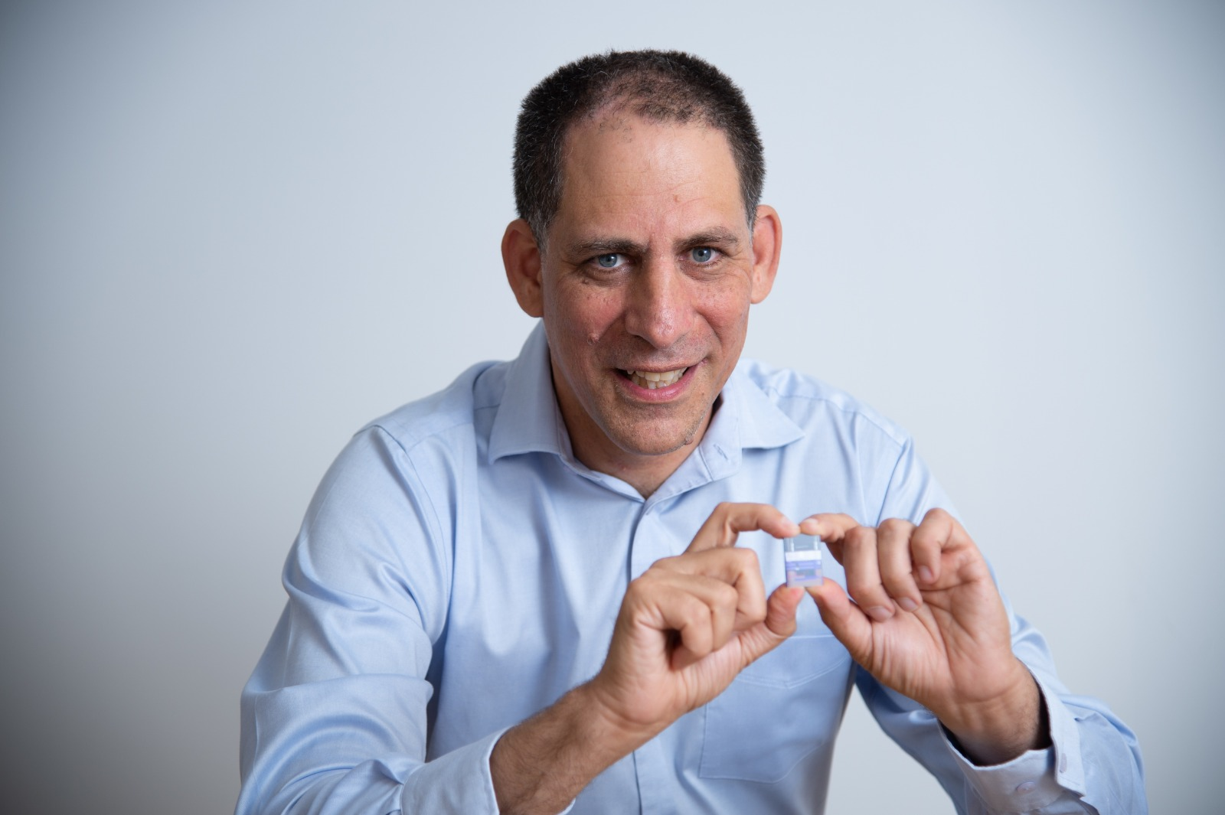
Short Bio:
Uriel Levy, professor of applied physics, The Hebrew University of Jerusalem, Israel. Dr. Levy received his PhD degree in Physics from Tel Aviv University in 2002. He was a postdoc researcher at UCSD during 2002 to 2006 before joining the Hebrew University as a faculty. His research interests include nanophotonics, light-matter interaction, optoelectronic nanoscale devices and nanoscale atomic physics.

