**Studying the structure and functions of cell membranes by single molecule approaches**

*Changchun Institute of Applied Chemistry, Chinese Academy of Sciences, China*

**Hongda Wang**

**Email: hdwang@ciac.ac.cn**

Cell membranes play a crucial role in various vital functions within a living cell, including separating the cell from its environment, facilitating cell signaling, and managing solute transportation. Gaining a comprehensive understanding of membrane structure at the molecular level is essential for a wide range of applications, such as drug screening, cancer treatments, and signal transduction control. Over the past fifty years, several theories have been developed, including the liquid mosaic model, lipid raft model, and protein domain model. However, the structure of cell membranes remains a subject of debate as these models are based on indirect evidence or non-native conditions, such as X-ray diffraction and electron microscopy. We utilized in-situ atomic force microscopy, super-resolution fluorescence microscopy, and cryo-electron microscopy to examine cell membranes at a molecular level. Our findings support three intriguing models of cell membrane structure: 1) For the red blood cell membrane (Semi-mosaic Model), proteins are partially embedded within the lipid bilayer rather than protruding out of the outer cell surface. The saccharides are located in the middle of lipid hydrophilic heads, and the membrane proteins are mainly situated on the cytoplasmic side of membranes. Membrane proteins tend to form clusters in cholesterol-enriched domains (or lipid rafts). 2) For mammalian tissue cell membranes (Protein Layer–Lipid–Protein Island model), the lipid bilayer is covered by a dense protein layer as the main functional component in terms of mechanical properties, signaling transduction, and material transport. Protein domains are located on the inner side of cell membranes, which may function as lipid rafts. 3) Based on the novel membrane structure and fluorescent live-cell imaging, we further propose a model of orderly and efficient vesicle transport, namely, the membrane-asymmetry-determined orderly organelle transport (MADOOT) model. Additionally, to examine the morphology and molecular composition of membrane protein aggregates within cell membranes, we have independently developed a microscope that combines morphological and super-resolution fluorescence imaging capabilities.

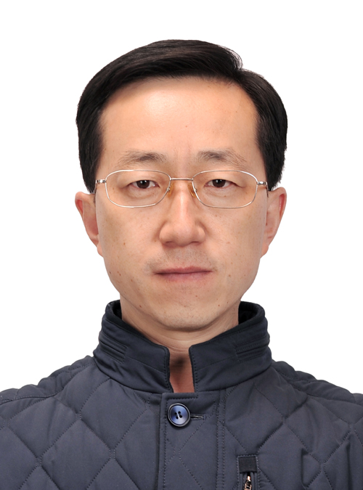

**Short Bio:**

**Hongda Wang**, a biophysicist, received his degree from the Department of Molecular Biology at Jilin University, P.R. China in 1995. Dr. Wang conducted postdoctoral research at the Max-Planck-Institute fur Molekulare Physiologie in Germany and the Biodesign Institute of Arizona State University in the USA from 2001 to 2007. Since 2008, Dr. Wang has served as a Principal Investigator at the Changchun Institute of Applied Chemistry, Chinese Academy of Sciences. In 2008, he was a visiting professor at Arizona State University. He is also a recipient of the National Science Fund for Distinguished Young Scholars. Dr. Wang's research focuses on studying the structure and function of cell membranes using various single-molecule techniques, particularly atomic force microscopy, molecular recognition imaging, super-resolution fluorescence microscopy, and cryo-electron microscopy. He has proposed the innovative Semi-mosaic model and Protein-Layer-Lipid-Protein-Island model for cell membranes. Dr. Wang has published more than 150 papers in journals such as Chemical Society Reviews, Nature Communications, PNAS, Cell Research, JACS, and Nano Letters.